**Steps for resolving ACH remit issue**

1. Have Ops or Joe restart JBOSS services on d1mod.doc1.bcbsaz.com. Ops has directions on how to do this.
2. Go to <http://d1mod.doc1.bcbsaz.com:8912/clientweb/HttpPublic?url=public/getUserIdentification> log in with credentials:
   1. username: **operations**
   2. password: look in the login.xls
3. Check to see if there any available agents listed by click on “Available Agents”. If the page is blank, like the image below, then nothing has to be done:

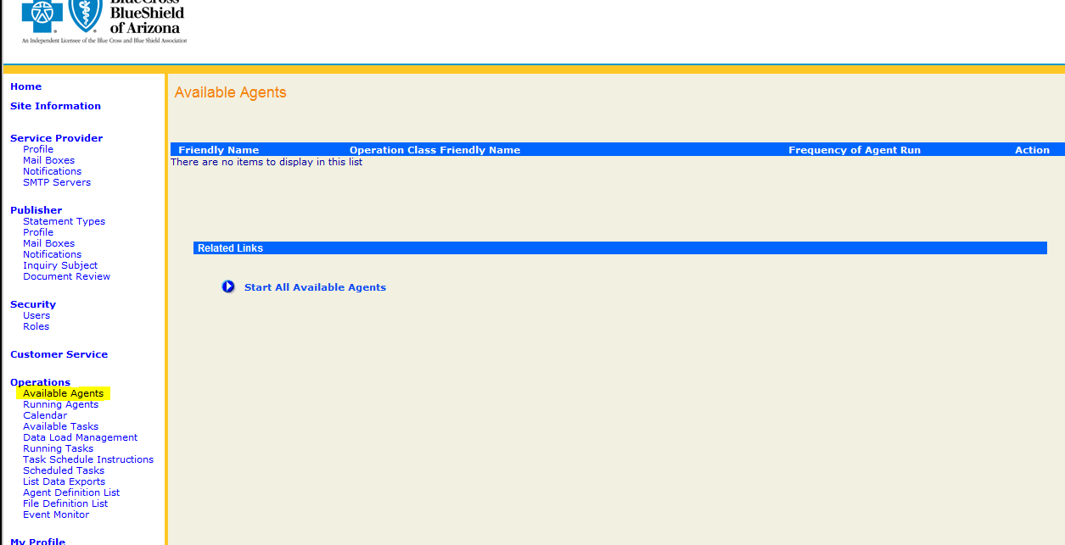

If agents are listed, click the “Start All Available Agents” link seen here:

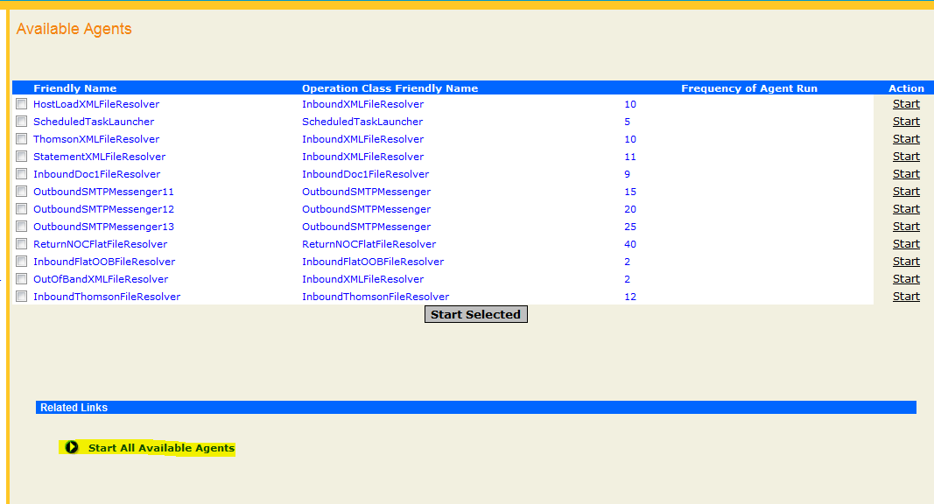

1. Click on the “Scheduled Tasks” link in the left menu:

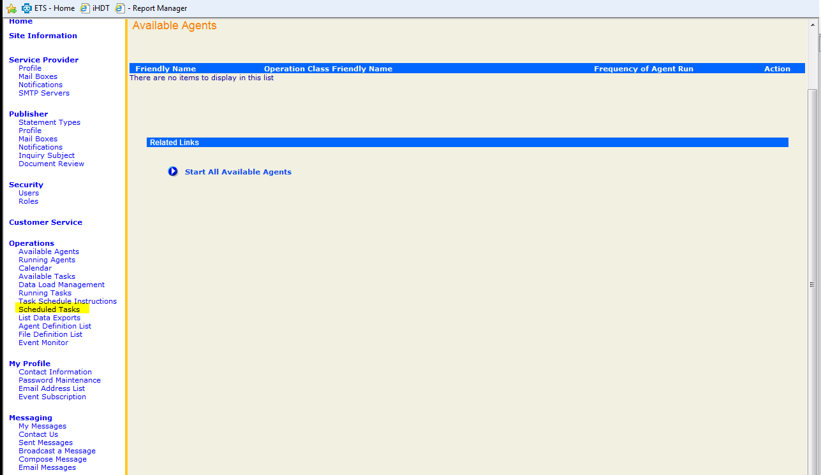

1. When ACH payments fail, you will see the following type of scenario, where you will see a failure at Step 1 of the BCBSAZ_ACH_Delivery_Set2_Step1 process:

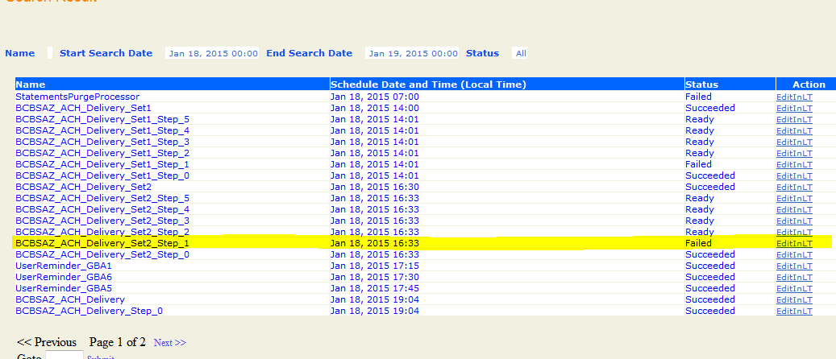

After JBOSS is reset, we need to create a new scheduled task to run to make the ACH payments are delivered.

1. At the bottom of the “Scheduled Tasks” screen, click “Add a Task”:
2. 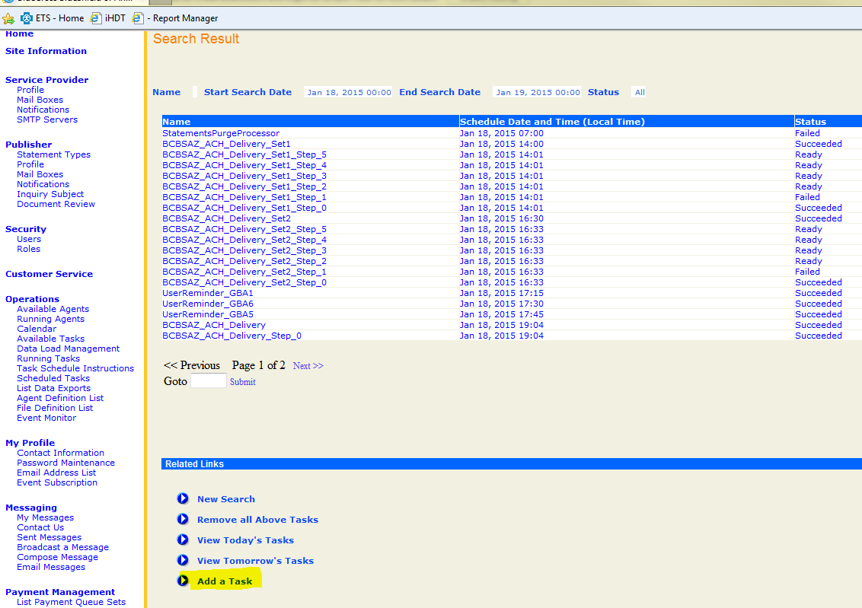
3. Click the “SchedInLT” link for the option BCBSAZ_ACH_Delivery_Set: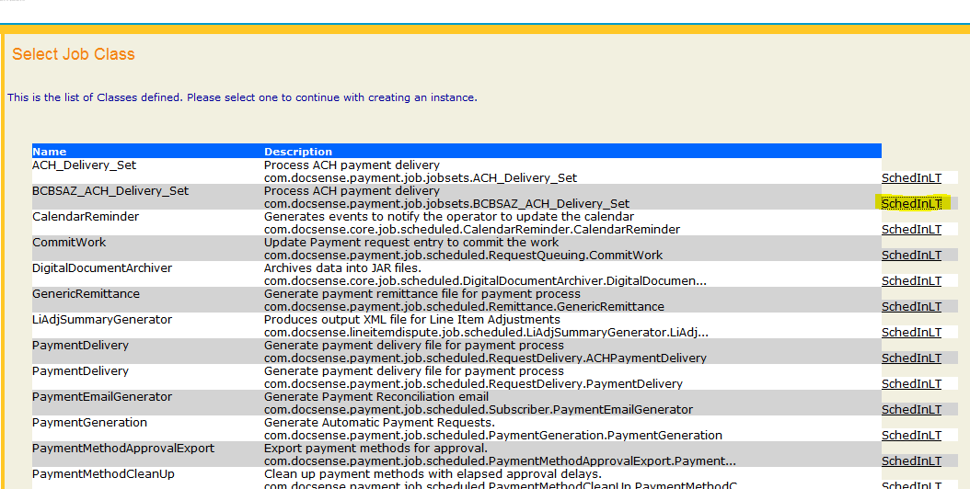
4. You’ll be presented with the following page: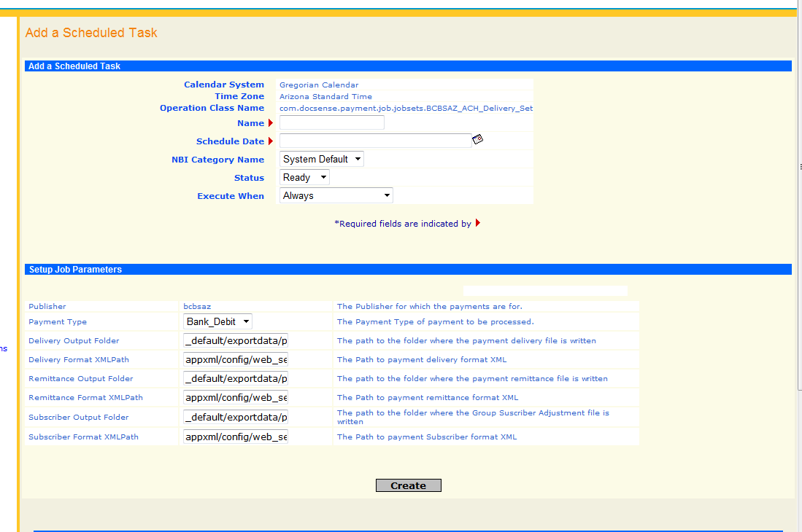

Fill the page out with the following details:

* Under “Add a Scheduled Task”
  + Name: ACH_Scheduled_Task
  + Schedule Date: Whatever date and time you want this task to run. Date is in military time (ex: Apr 29, 2015 12:00 is a good date)
  + NBI Category Name: 2015 Calendar (substitute for the current calendar year if needed)
  + Status: Ready
  + Execute When: Always
* Under “Setup Job Parameters”
  + Payment Type: Bank_Debit
  + Delivery Output Folder: D:\e2\bcbsaz_data\payment
  + Delivery Format XML Path: D:/e2/format_xml/ACH_Payment_Delivery.xml
  + Remittance Output Folder: D:\e2\bcbsaz_data\payment
  + Remittance Format XMLPath: D:/e2/format_xml/ACH_Payment_Remittance.xml
  + Subscriber Output Folder: D:\e2\bcbsaz_data\payment
  + Subscriber Format XMLPath: D:/e2/format_xml/ACH_Payment_Subscriber.xml

1. Hit the Create button at the bottom of the page. The scheduled task will begin according to the time you’ve set up under “Schedule Date”. This process takes about 30 to 40 minutes. It’s recommended to keep an eye on the “Scheduled Tasks” screen, because as the process runs, you will see the Status for each step of the job change from “Ready” to “Succeeded”. If there is a problem, you will see “Failed” again, but I haven’t seen the job start and not finish after resetting JBOSS. If everything is successful, the job is complete.

**Steps for Joe or a DBA to check to make sure all ACH files process correctly:**

Sometimes after re-scheduling the job, there will still be some delivery failures that need to be corrected. You can see delivery failures after the scheduled ACH job is done by following these steps:

1. Click on “List Payment Queue Sets”. You will be taken to a page of queued ACH payments. Click on all of the bcbsaz links that have to deal with the date there was an issue with. In this example, there was an issue with 2/17/2015: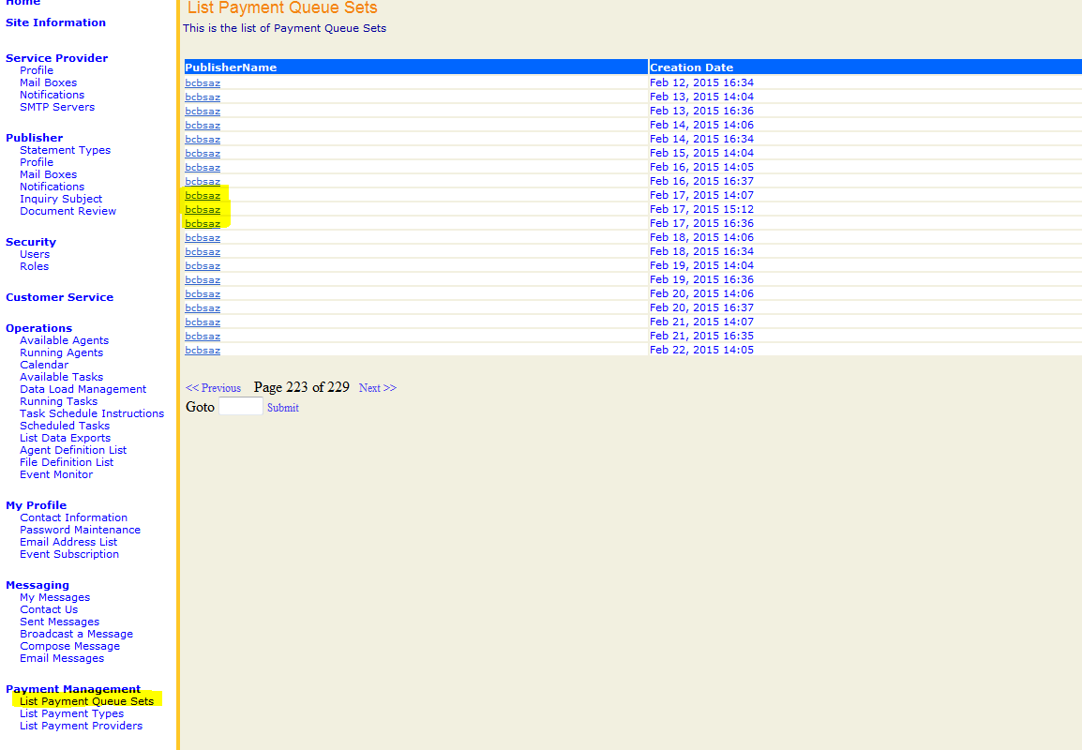
2. If one of the links has any Failed Payment Queue entries, like below, take note of the QueueSetId located in the URL. In this example, the QueueSetId is 79705: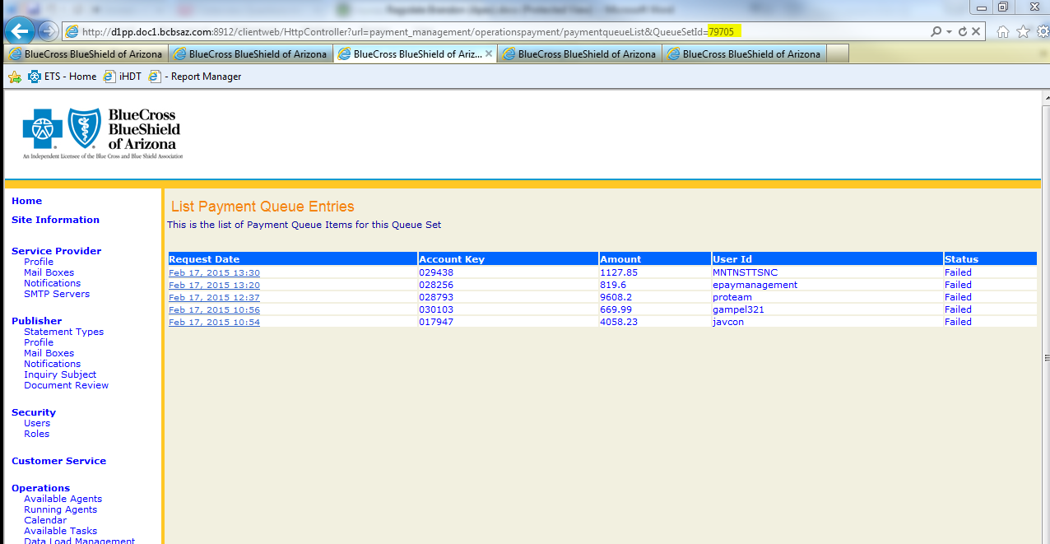
3. Run the following query under MP-DOC-SD01\SS01P.Payer using the QueueSetId to replace the “'XXXXX'” below:

USE PAYER

SELECT *

FROM [payer].[dbo].[PaymentRequest]with(nolock)

WHERE PaymentQueueId = 'XXXXX' and status = '10'

1. Copy the “PaymentRequestId” that get returned. There will usually be several PaymentRequestIds, seen in the example below: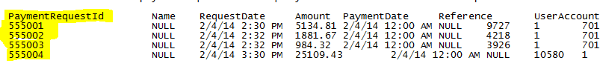
2. Create a Serving Blue change request for Joe (or a DBA) to run the following query based upon the example with the PaymentRequestIds above to fix the issue:

USE [payer]

GO

UPDATE PaymentRequest SET Status = 0, ProcessID = null, PaymentQueueId = null

WHERE PaymentRequestId IN (555001,555002,555003,555004)

1. After Joe runs the SQL statement above, the next time the ACH job runs, these payments will go out. Michelle Plumey (Revenue Tech) can determine whether the ACH payments ran properly.